**Technical Bulleti**

**——Firmware and software update and Modification points**

1. **GD100 Firmware Update**

* **GD100 firmware：update_gd100_v1.10.20_b20250302.bin**
* **GD100 Control firmware：update_APMrover2-v2_v4.6.31_b20250211.px4**

Release date：March 5, 2025

Version Number：v1.10.20 + v4.6.31

Version type: Official firmware

Version applicable scope: All ship types, GD100 hardware version 1.2 and above

* **Modification points：**

1.Before the firmware, ADCP directly uses the positioning data from the primary antenna, there will be a bias, the new firmware adds the value of offset, which improves the accuracy of ADCP positioning data.

2.Solve the problem that the USV receives differential data but doesn’t decode it, and the GNSS status is always single with the Huace I90+CHC352 protocol.

3.Solve imu data loss and exit initialization problem.

4.Solve the problem of the echo sounder not bottom tracking after the water depth filter button is switched once.

5.Solve the problem of probabilistic loss of .sd files in the record1 folder.

6.Solve the problem of occasional loss of control in the water for USV equipped with V1.3 power box.

7.Solve the problem that a waypoint and a target point on the Easysail route are always highlighted and not changed during the ship autopilot process.

8.Solve the problem of frequent head turning and serious sticking to the edge during bank avoidance (semi-automatic mode).

9.Optimize the remote controller disconnection alarm logic, to the limit of the toggle control, will not frequently prompt alarm information.

* **Firmware upgrade instructions：**

1.The host firmware and control firmware must be upgraded together, and one firmware cannot be upgraded separately.

2.After upgrading the firmware, you need to set the corresponding motor parameters on the AP or Easysail software according to the customer's motor model.

1）Hardware version check：GD100 hardware version 1.2 and above.

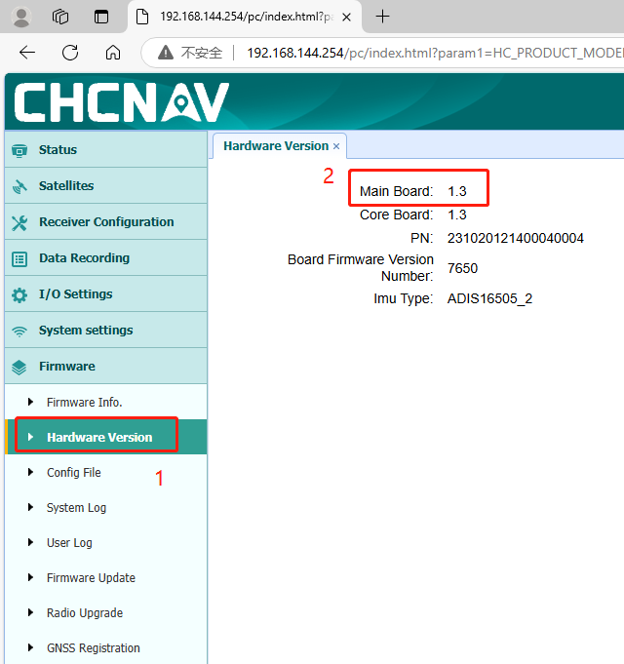

1. Check the motor parameters：Motor parameters have three types: 9S-265KV, 9S-200KV, and other motors except the above two.

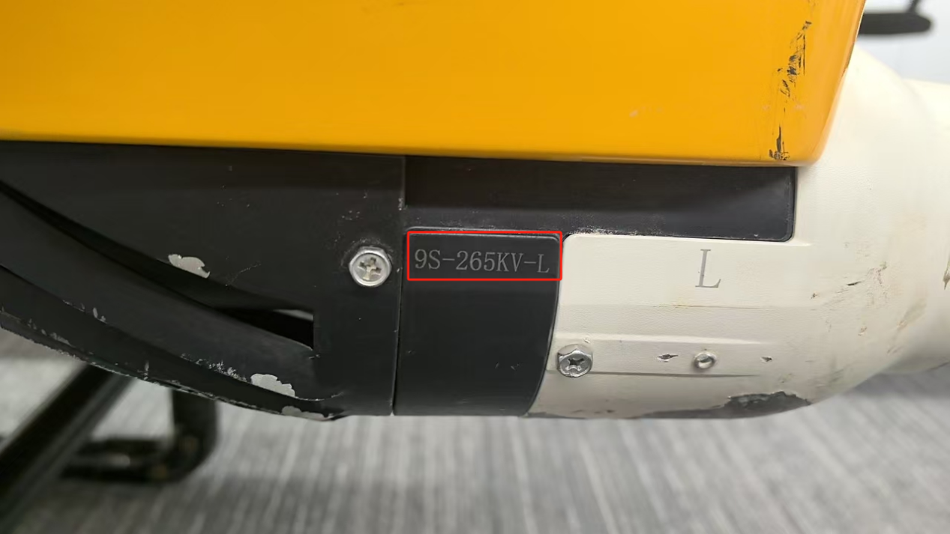

1. Set the motor parameters in Easysail software：

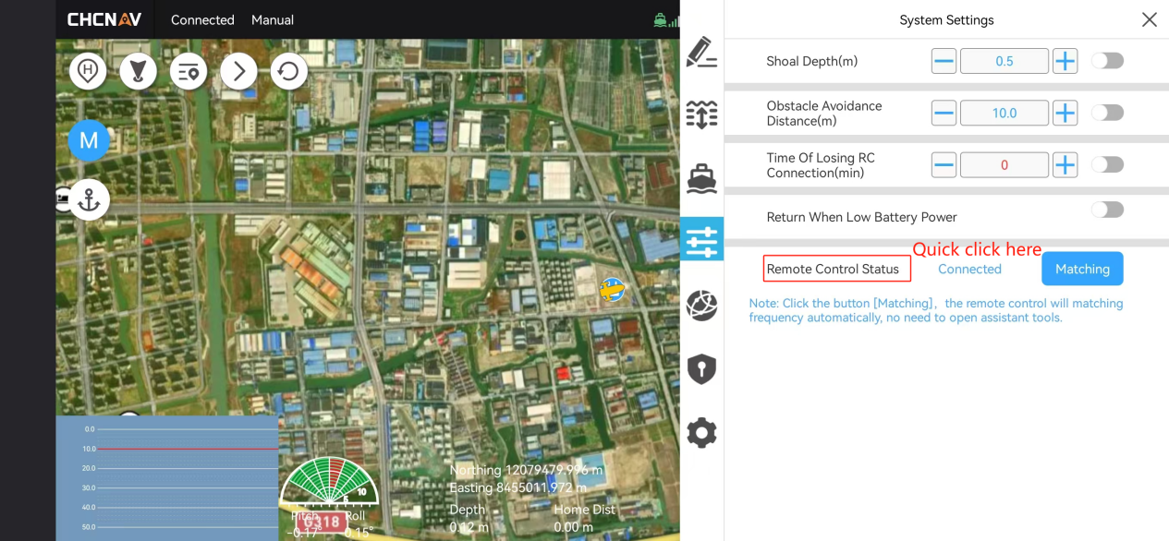

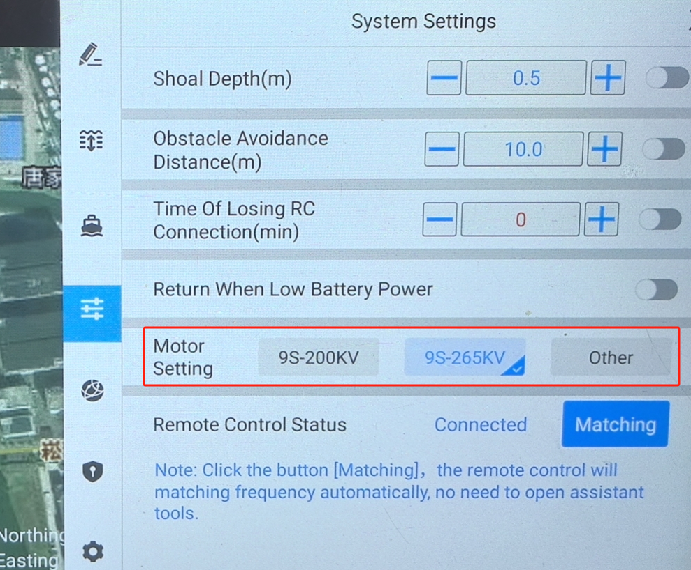

1. Select the corresponding motor parameters and confirm.
2. Restart the USV and Easysail to double check if the motor parameters are set successfully.
3. Or we can set the motor parameters in AutoPlanner software：

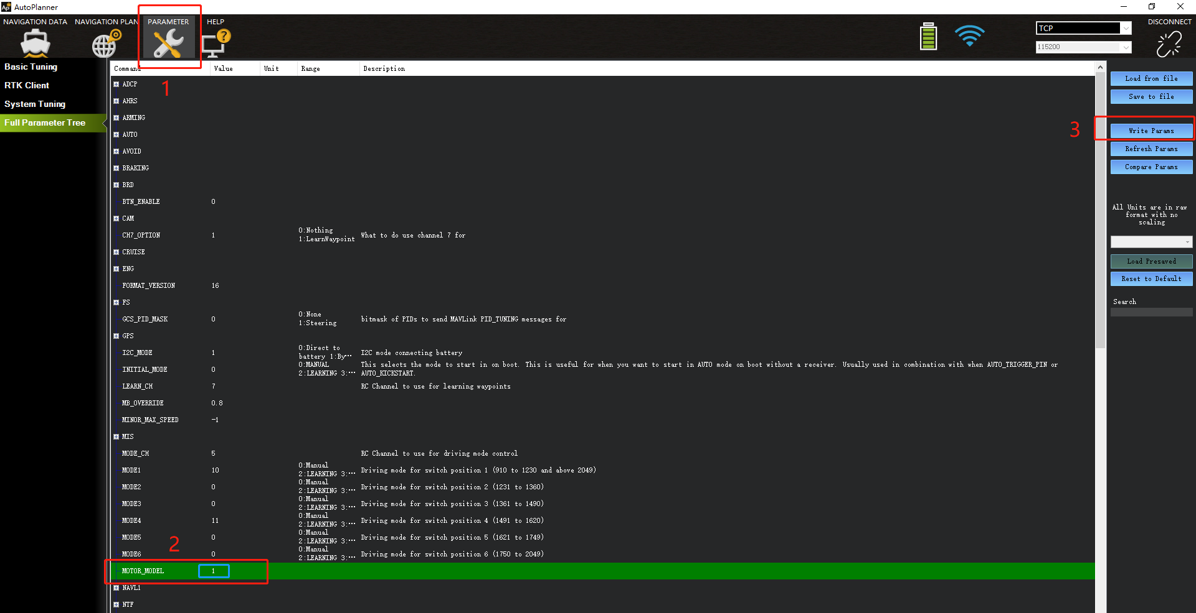

1. Motor model：0 is others，1 is 9S-265KV，2 is 9S-200KV.
2. Restart the USV and AutoPlanner to double check if the motor parameters are set successfully.
3. **Easysail Software Upgrade**

* **Easaysail software:EasySail-1.5.0.2.20250310-Release-Android**

Release date: March 10, 2025

Version number: v1.5.0.2

Version type: Official version

Version applicable scope: All

* **Modification points：**

1. Support ADCP flow measurement and data post-processing.
2. Supports multibeam measurements.
3. Support preset route mileage display.
4. Supports route saving.
5. Supports voice prompts and volume control.
6. Supports one-click import of HydroSurvey projects.
7. Supports battery maintenance information display.
8. Fixing known issues.

Shanghai Huace Navigation Technology Co., Ltd.

Marine Technology Department

March 11, 2025